AI ASSISTED CODING

Assignment-7.3 :

**2403A52107**

**Pavani Voddepalli**

**Batch : 24BTCAIAI05**

**TASK-1 :** Analyze the ERROR and evaluates the addition of two numbers dynamically in Python

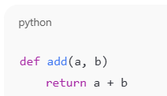

CODE & OUTPUT : FOR GEMINI AND CURSOR

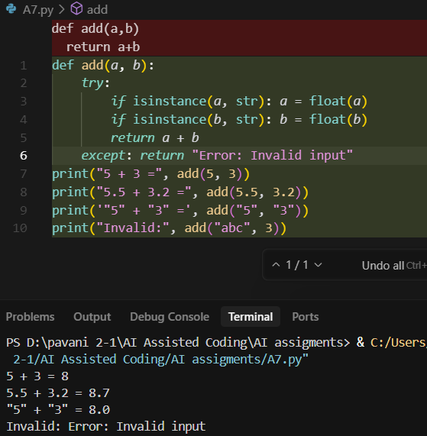

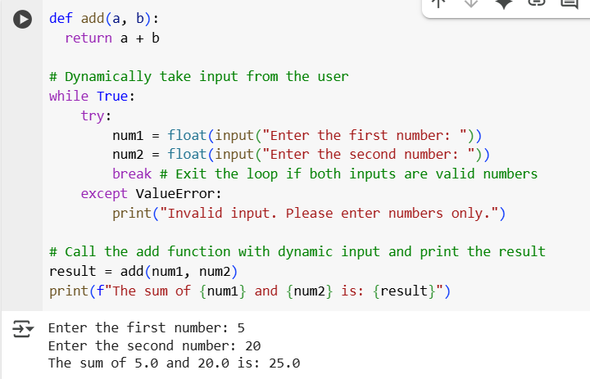

**TASK-2:** Fix a logic error in a loop that causes infinite iteration and evaluates the changes required modifying the code

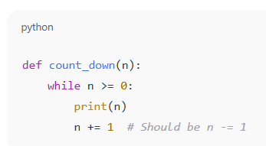

CODE& OUTPUT :

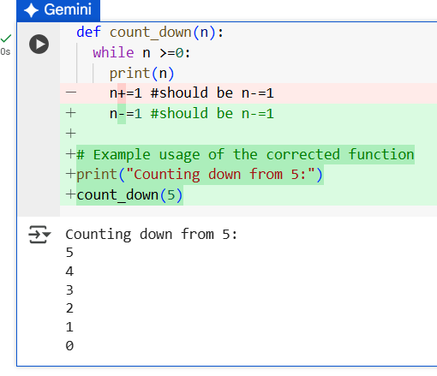

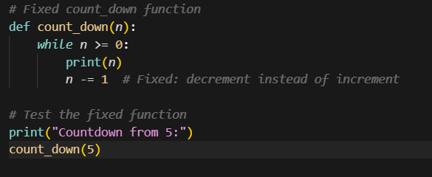

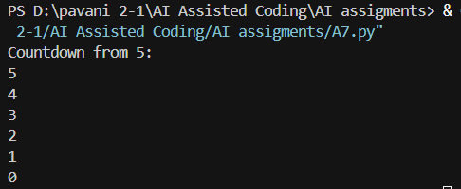

EXPLANATION : This part defines a function called count_down that takes one argument, n.

* while n >=0:: This is a loop that continues as long as the value of n is greater than or equal to 0.
* print(n): Inside the loop, the current value of n is printed.
* n-=1: This line is the fix for the infinite loop. It decreases the value of n by 1 in each step. This ensures that eventually, n will become less than 0, and the loop will stop. The comment #should be n-=1 indicates the intended correction.

# Example usage of the corrected function  
print("Counting down from 5:")  
count_down(5)

This section shows how to use the count_down function.

* print("Counting down from 5:"): This prints a message to the console.
* count_down(5): This calls the count_down function with n set to 5, starting the countdown from 5.

**The Logic Error:**

* The function is called count_down but it's **incrementing** (n+=1) instead of **decrementing**
* Since n keeps getting bigger, the condition n >= 0 will always be true
* This creates an **infinite loop** that never ends

**TASK-3 :** Debug a runtime error caused by division by zero. Let AI insert try-except.

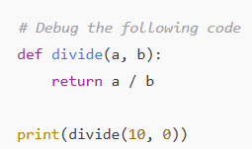

CODE & OUTPUT :

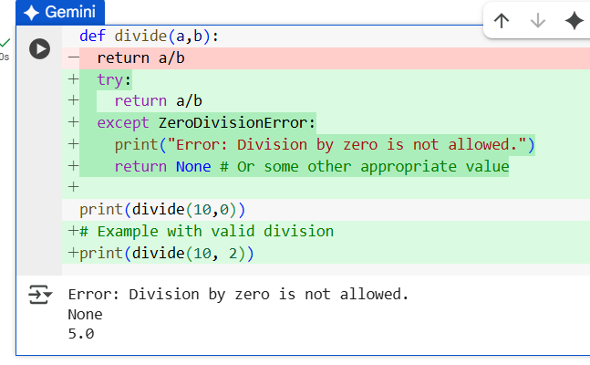

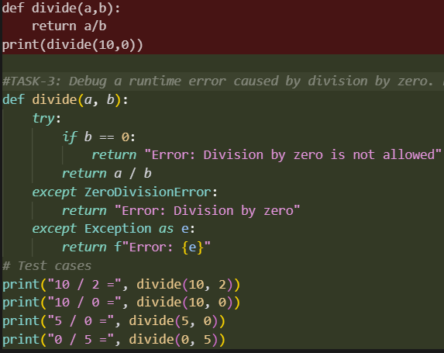

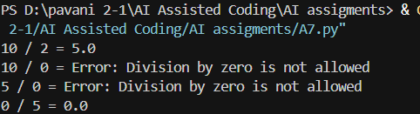

Explanation :

**The Runtime Error:**

* When b = 0, division by zero occurs
* Python raises ZeroDivisionError: division by zero
* The program crashes without proper error handling

**TASK -4 :** Debug the python program , evaluate the error and modify the code with the appropriate dynamic output

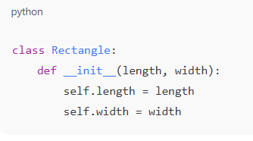

CODE & OUTPUT :

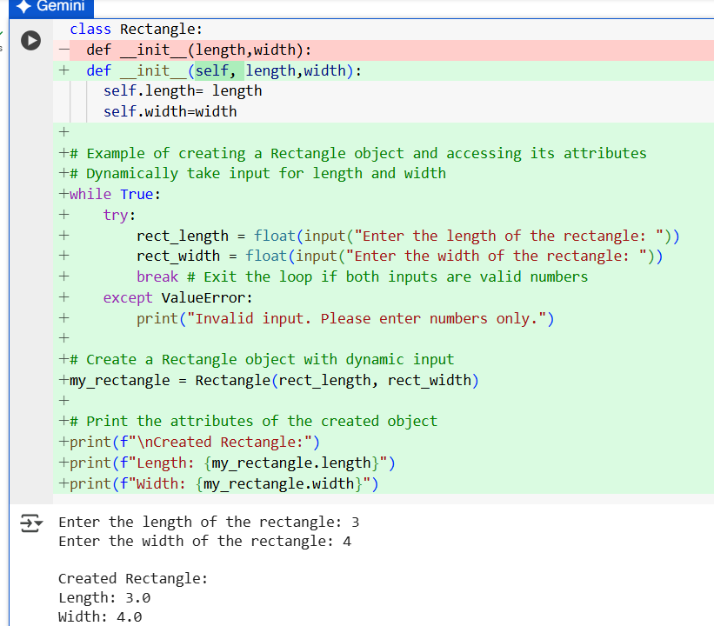

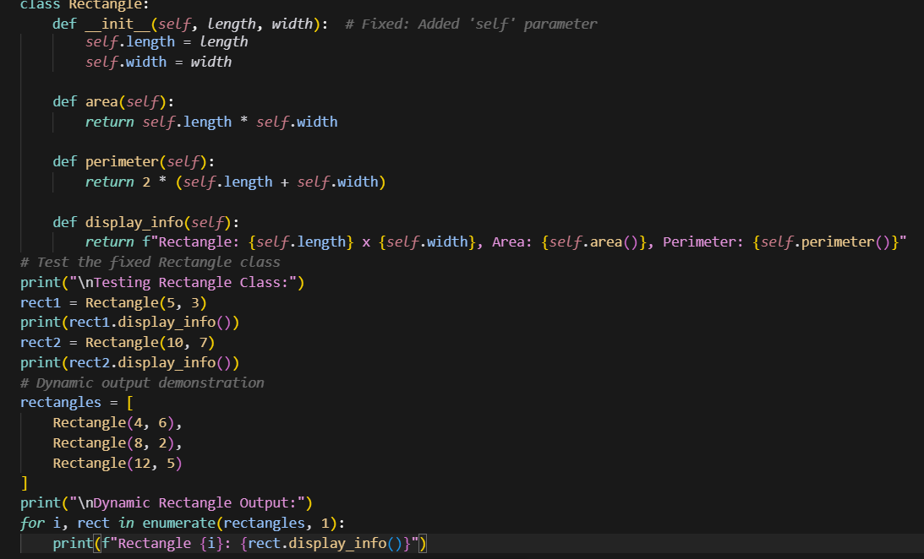

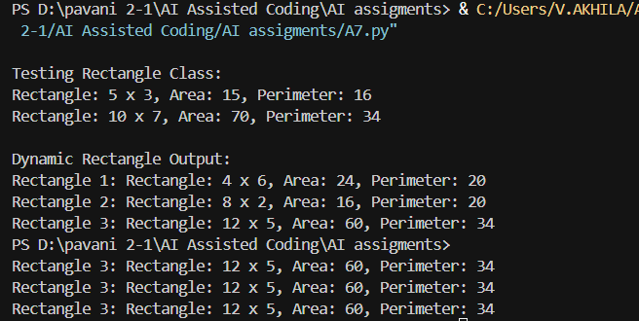

EXPLANATION :

**The Error:**

* Missing self parameter in the __init__ method
* Python will raise TypeError: __init__() takes 2 positional arguments but 3 were given
* The self parameter is required for all instance methods in Python classes

**TASK-5 :**

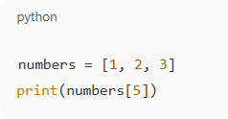Generate a python program recorrecting to resolve the access of an invalid list index checking length or using safe access logic

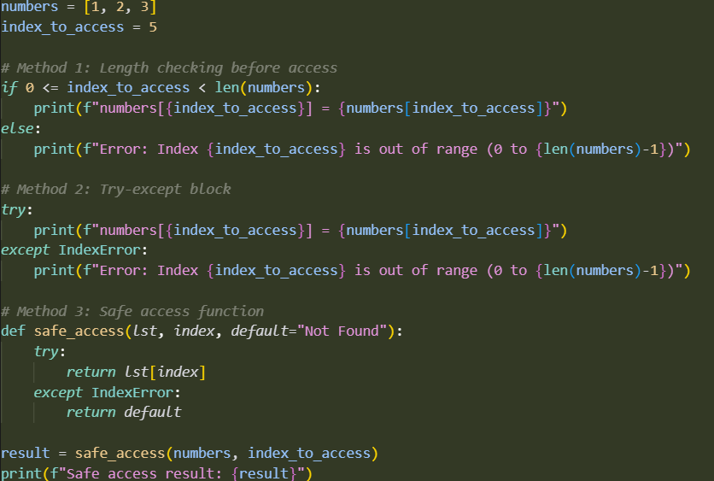

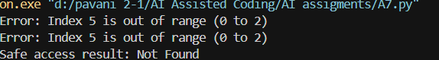

1. **IndexError**: The list numbers has only 3 elements (indices 0, 1, 2)
2. **Invalid Access**: Trying to access numbers[5] attempts to get the 6th element, which doesn't exist
3. **No Error Handling**: The code had no protection against accessing invalid indices